EEE 311 ML PROJECT

PROGRESS REPORT

Nowadays, with the development of technology, internet shopping has become a part of people's lives. As a result of this situation, e-commerce platforms have gained importance to meet the needs of users and are becoming more important day by day. Among these platforms, the fashion category attracts a lot of attention due to customers' personal preferences and style expectations. Fashion recommendation systems are very important and useful for both users and e-commerce platforms. Fashion recommendation systems provide fashion recommendations to users. These suggestions can be in the form of a single product or in combination. By offering personalized recommendations to users, it attracts customers' attention and makes the user's decision-making process much easier. This is a positive result for e-commerce platforms and thus enables them to increase sales figures and generate higher revenue. However, there are some challenges faced by fashion recommendation systems.

First of all, fashion recommendation systems need large and high-quality data sets to provide accurate and personalized recommendations to users. If the data set is limited, this makes it difficult for the fashion recommendation system to accurately analyze the general user base. Another problem is that fashion trends change over time. Fashion is a highly variable field that depends on trends. Users' fashion tastes evolve and change over time. Fashion recommendation systems must quickly adapt to changing trends. This requires constant updating of fashion recommendation systems and data sets. Otherwise, fashion recommendation systems will be insufficient to analyze users' current preferences.

Fashion recommendation systems first started in 1990, based on studies in Collective Intelligence. The first user-oriented recommendation system was developed by Gold-berg, Nichols, Oki and Terry in 1992 and began to be used for commercial purposes. However, this system only allowed users to rate messages as good or bad products. After the 2000s, e-commerce platforms began to use recommendation systems. However, this application was in development until 2007-2008. Firstly, fashion products, just like other products, were recommended based on the user's purchasing history. In the following years, with the development of computer vision systems, personalized fashion systems were developed. Today, models such as multilayer perceptron (MLP), recurrent neural network (RNN), k-nearest neighbor (kNN), convolutional neural networks (CNN), Bayesian networks, generative adversarial network (GAN) and autoencoder (AE) are used for fashion recommendation systems. . Fashion recommendation systems have become very popular in recent years. Amazon, eBay, Shopstyle are examples of e-commerce platforms that use fashion recommendation systems.

For our project, we took a look at similar projects that had been done before and discovered notebooks of similar projects. Examining these notebooks allowed us to get an idea about which model we could use. As a result of the review, we saw that all projects were CNN (convolutional neural networks) based. In addition, the projects are based on the deep learning model.

Our project aims to implement a recommendation system application that finds similar products from a collection of images containing clothing items, using a specific reference image. Reference product (input) is taken and analyzed. It is compared with the products in other images in the data set and the most similar products are selected. These selected products are shown to the user as recommended products (output). Our fashion recommendation system utilizes a pre-trained ResNet50 model. Resnet50 is a 50-layer network trained on the ImageNet dataset. ImageNet is an image database with more than 14 million images belonging to more than 20 thousand categories, created for image recognition competitions. With Resnet50, we obtain the vector features of all images in the reference image and dataset. The illustration below demonstrates the functionality of ResNet-50 through an example.

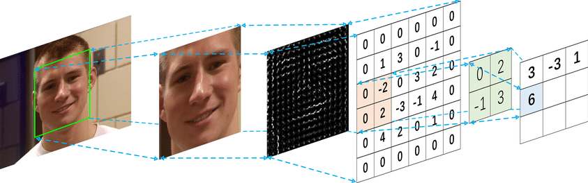

After the feature vector is obtained for all images, the similarity of each image in the dataset to the reference image is calculated with the cosine_similarity metric. The cosine similarity measures the cosine of the angle between two images. By comparing the similarity between two image vectors, it helps to identify similarities in the features of the images. The 3 images that are most similar to the reference image are selected and the selected images are shown as suggestions to the user. The image below is an example of a fashion recommendation system.

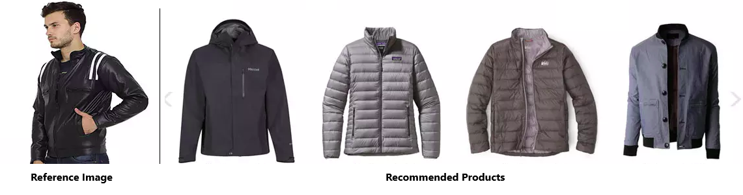

In our recent studies, the similarity ratios have consistently ranged between 0.50 and 0.70 on average. An important problem in our project is that when calculating the similarity rate, not only the product but also other factors such as the model's face are included in the similarity rate calculation. In our next work, we aim to work on segmentation and develop the fashion recommendation system to overcome this problem.

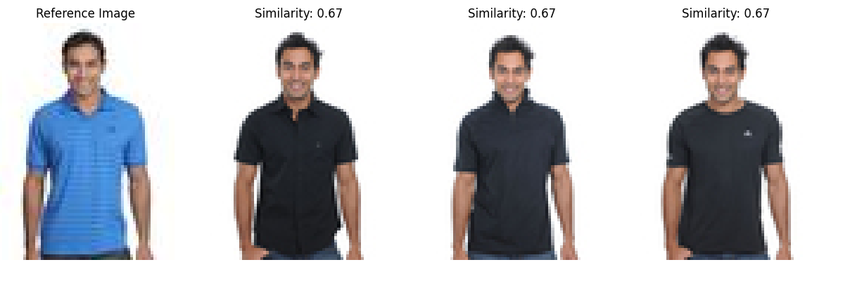

References:

<https://www.mdpi.com/2227-9709/8/3/49>

<https://www.youtube.com/watch?v=xanJe6e8Xuw&t=3717s>